

**Muhammad Talha Ramzan**

**2330-0141**

**BS AI**

**Task no 01**

|  |
| --- |
| Creating thread 0 Creating thread 1 Creating thread 2 Creating thread 3 Creating thread 4 Creating thread 5 Creating thread 6 English: Hello World! from thread 0 English: Hello World! from thread 1 English: Hello World! from thread 2 English: Hello World! from thread 3 English: Hello World! from thread 4 English: Hello World! from thread 5 English: Hello World! from thread 6 |
|  |

**Output**

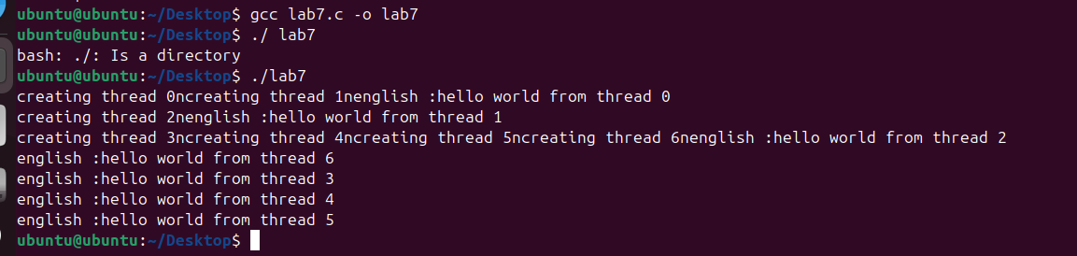

**Task no 02**

|  |
| --- |
| Sample Output Child process: The square of 2 is 4 Parent: Child process with PID 12345 finished. Child process: The square of 4 is 16 Parent: Child process with PID 12346 finished. Child process: The square of 6 is 36 Parent: Child process with PID 12347 finished. Parent: All child processes have finished calculating the squares. |
|  |

**Output**

